**Case study**

1. **Erd diagram**

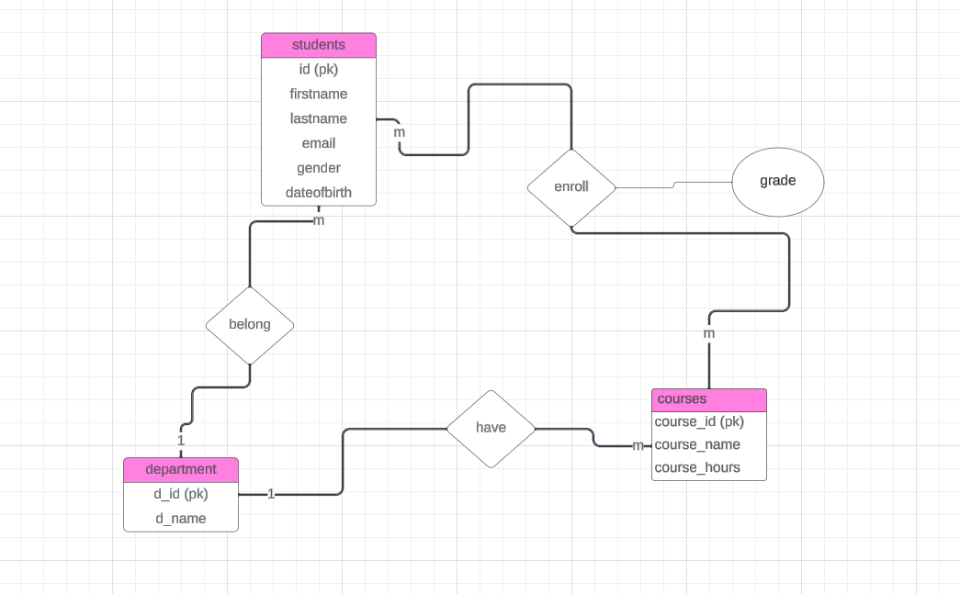

1. **Schema diagram**

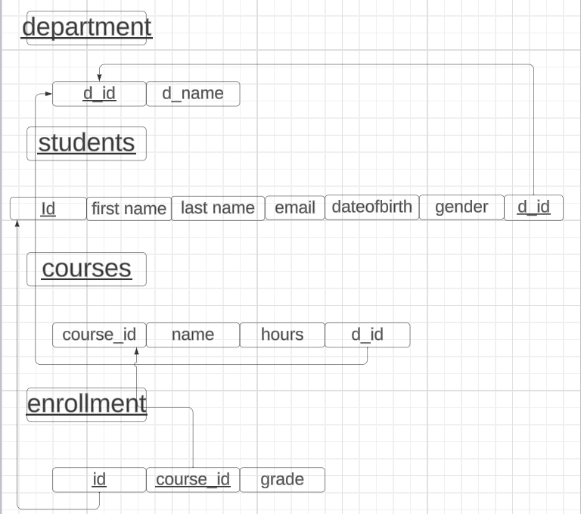

1. **Normalization**

1nf:

No multivalues , repeating groups

departments:

d_id , d_name

students:

id , first_name , last_name , email , dateofbirth , gender , d_id

courses:

course_id, course_name , course_hours , d_id

enrollment:

course_id , id , grade

2nf , 3nf:

2nf :All non-key attributes fully dependent on the primary key

3nf: no transitive dependencies

departments:

d_id , d_name

students:

id , first_name , last_name , email , dateofbirth , gender , d_id

courses:

course_id, course_name , course_hours , d_id

enrollment:

course_id , id , grade

**sql scripts:**

1. **Create tables**

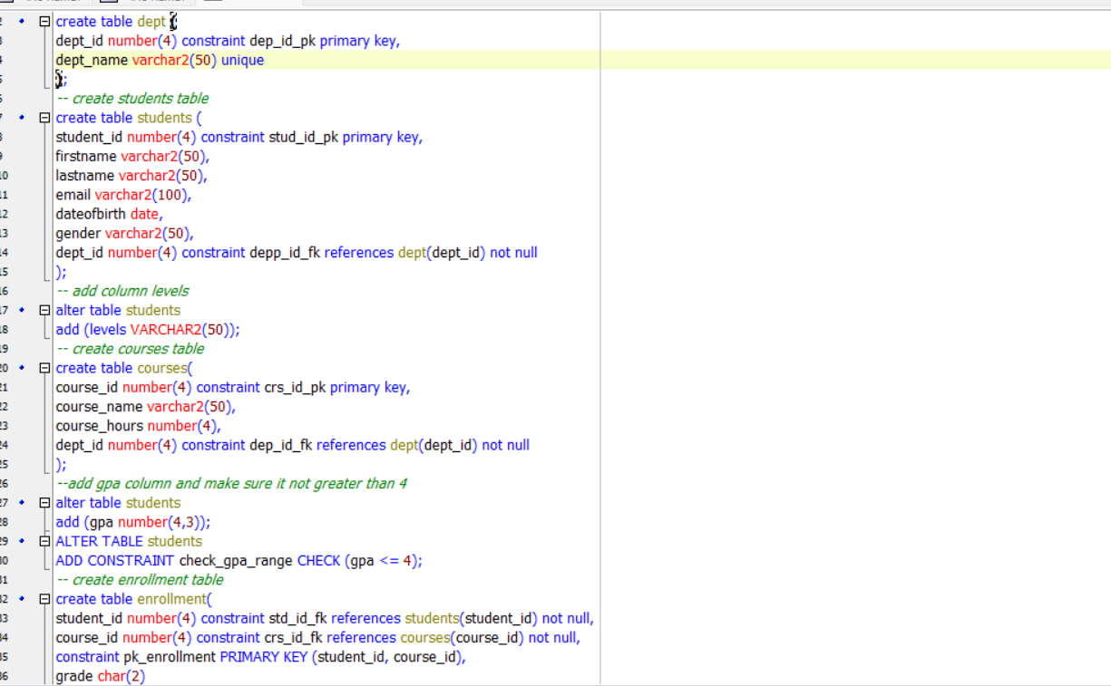

**Courses table:**

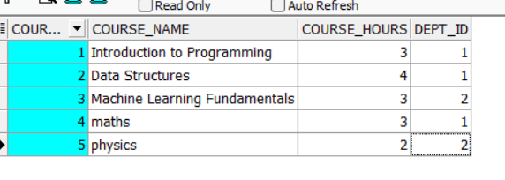

**Students table:**

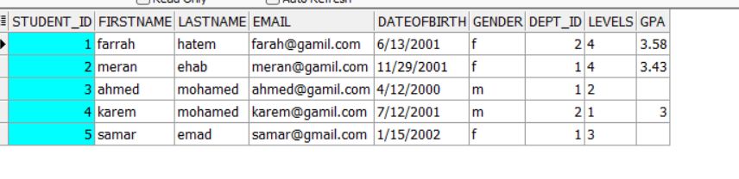

**Dept table:**

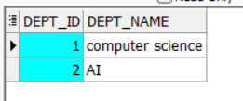

**Enrollment table:**

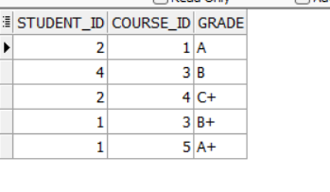

1. **Insert into tables**

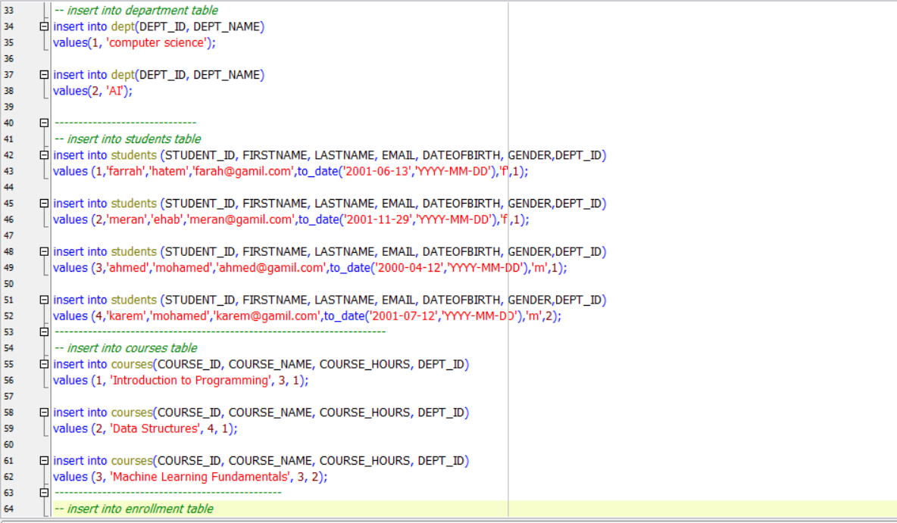

1. **Testing**

